PERSONALIZED E-LEARNING COURSE RECOMMENDATION SYSTEM
Conclusion, Future Scope and References
Department of Computer Science and Engineering, [COLLEGE NAME]
Batch C7 (CSE-C) · Academic year [ACADEMIC YEAR]
Table 1: Project team
S.No. | Student name | Roll number
1 | PITTALA AKHILA | 23K91A05J3
2 | MUNDALA SANDHYA | 23K91A05G5
3 | MULA THANUJ REDDY | 23K91A05G4
4 | MAJJIGAPU JAGADESHWAR REDDY | 23K91A05E1

Project guide: K GAYATHRI
Chapter and section numbers quoted in the text (for example Section 6.6 or Chapter 8) refer to the full project report, 17.Final Document. Figures and tables in this document are numbered from 1.

CHAPTER 9: CONCLUSION

9.1 Summary
The project set out to build a personalised course-recommendation system that profiles a learner, matches the catalogue by content, adapts to feedback and orders the result into a learning path, and to evaluate it honestly. It delivers LearnPathIQ: a FastAPI and SQLite back end with eighteen JSON routes, a React front end with twelve screens and the original server-rendered interface, a 24-course catalogue, an eight-term hybrid ranker with a plain-language reason on every card, a measurable feedback loop, a learner-success model, an estimated benefit for five learning actions, an offline policy evaluation and a fairness audit. The work is backed by 5 automated tests, a 33-check smoke test and a responsive-layout check. All learned models are trained on a reproducible synthetic data set that imitates the structure of the Open University Learning Analytics Dataset; the real data were never used.

9.2 Objectives against outcomes
Table 2: The six objectives and their outcome
# | Objective | Status | Evidence
1 | Build learner profiles capturing interests, current skills, goals and completed courses. | Achieved | Ten-field profile stored per learner; completed courses recorded as complete events
2 | Construct a course catalogue with topic, level, prerequisite and outcome metadata. | Achieved | 24 courses, 9 categories, nine metadata fields
3 | Implement collaborative filtering over learner interaction history. | Not achieved | No real multi-learner history exists; the behavioural term is per learner
4 | Implement content-based matching between learner profile and course metadata. | Achieved | TF-IDF cosine plus skill, topic and goal terms; P@3 0.800 on the persona check
5 | Combine both into a hybrid recommender and order the output into a coherent learning path. | Achieved | Eight-term hybrid (P@3 0.733) and a six-step path ordered by level then score; no prerequisite graph
6 | Evaluate using precision, recall and learner feedback on recommendation relevance. | Partly achieved | AUC 0.603, F1 0.415, persona P@k and MRR; no real-feedback precision or recall, no user study

Four objectives were achieved (profiles, catalogue, content-based matching, and the hybrid score with its learning path, which is ordered by skill level and score and has no prerequisite graph), one partly (evaluation) and one not at all (collaborative filtering across learners). The reasons are stated plainly: no real multi-learner history was available, so the behavioural term in the score reflects only the one learner's own events, and no real learner feedback was collected.

9.3 Key findings
• The success model is weak. The deployed Logistic Regression reaches a test AUC of 0.6028 (six-seed mean 0.614 +- 0.012) and an accuracy of 0.594, only a few points above the 0.562 majority-class rate. Adding the hidden assessment score lifts AUC to 0.800, so the weak signal is a property of the synthetic data, not a coding fault.
• The hybrid beats popularity but not content-only matching. On ten author-written personas P@3 is 0.200 (popularity), 0.800 (content-only) and 0.733 (hybrid). The drop-one-term ablation shows that the topic and content terms matter most (P@3 falls to 0.600 and 0.667 without them).
• Ranking adapts at once. Six events raise the score of the studied course from 0.4867 to 0.5514, push the dismissed course from rank 3 to 4 and move the success estimate from 0.202 to 0.324.
• Action advice is unstable and weak evidence supports it. Estimated benefits change sign after a few events, and the offline policy values (IPS 0.0088, SNIPS 0.6652, DR 0.4355) rest on an effective sample size of 9.1 of 2,640 rows.
• The audit finds a gap. F1 is 0.305 for the oldest age band against 0.415 for the youngest, on a small group.
• The engineering is sound at demonstration scale. A ranked list of eight courses takes 32.8 ms on average (p95 42.4 ms) on the development machine; 5 of 5 tests and 33 of 33 smoke checks pass.
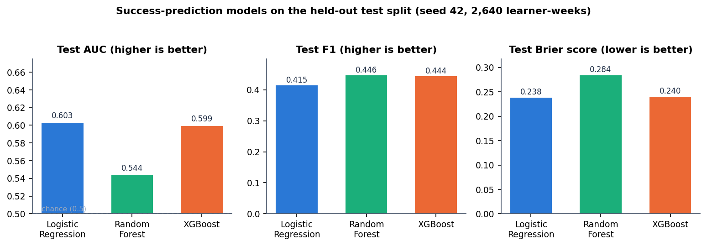
Figure 1: Summary of the success-model comparison on the held-out test split
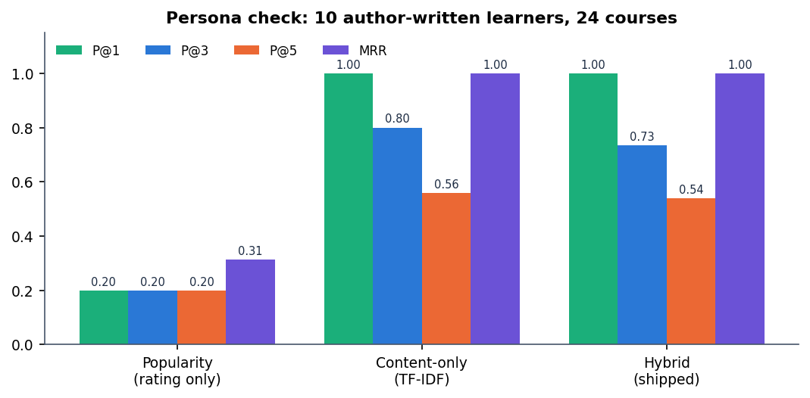
Figure 2: Summary of the persona check: popularity, content-only and hybrid rankers

9.4 Practical applications
• A teaching demonstrator for how a hybrid ranking, a feedback loop and an explanation fit together in a small course platform.
• A research scaffold: the training script, the offline policy evaluation and the audit can be re-run on real OULAD data once it is loaded, and the persona check can be replaced by real feedback.
• A starting point for a recommendation module in a small learning portal, after the gaps listed below are closed.

9.5 Honest summary of what is missing
• Real data: nothing here is validated on real learners.
• Collaborative filtering across learners and a prerequisite graph.
• The base paper's reinforcement-learning agent.
• Real feedback: no user study and no live experiment, so precision and recall against real relevance were not measured.
• Production hardening: caching, identity, a server database and load handling.

CHAPTER 10: FUTURE SCOPE
Each item below is tied to a gap that the measurements in Chapter 8 exposed, so the order follows the strength of the evidence, not novelty.

10.1 Real data
• Train and evaluate on the real OULAD data [4] (CC BY 4.0). The synthetic generator caps the signal at AUC about 0.60; real behaviour may carry more or less. The existing script already probes the dataset page; the missing step is loading the student, VLE and assessment tables into the same eight features.
• Re-run the seed study, the ceiling check and the fairness audit on the real data and report the results next to the synthetic ones.

10.2 Better recommendation models
• Collaborative filtering over learner histories (objective 3), for example matrix-factorisation or graph models such as LightGCN [17], once a real interaction log exists; combine it with the content score, as the companion paper on time-to-event filtering does [3].
• Semantic content matching. Replace TF-IDF by sentence embeddings trained contrastively, as in the isotropy-optimised BERT approach [2], to match learners and courses that share meaning but not words.
• Learn the score weights from feedback (learning to rank) instead of the hand-set 0.30/0.15/0.15/0.12/0.10/0.08/0.05/0.05; the ablation already shows two terms (skill and rating) that slightly lower P@3 as weighted.
• Make the suggested action course-specific, so that the action line on each card differs, which the current learner-state-only estimate cannot do.

10.3 Policy learning and evaluation
• Implement the base paper's policy learner: a causal-regularised Actor-Critic agent [1], [9], [18] on top of the uplift estimates, with fitted-Q baselines.
• Make the offline evaluation trustworthy: sweep the propensity clip and weight cap, use an action-conditional outcome model for the doubly robust value, and report confidence intervals; the current effective sample size of 9.1 shows why.
• Run a live randomised test of the suggested action before any claim about its benefit.

10.4 Learning paths
• A prerequisite graph and knowledge tracing [19], [10] so that the path is ordered by what a learner must know, not only by level and score.
• Completed-course handling as a first-class profile field rather than a complete event.

10.5 Evaluation with learners
• A user study with real learners rating relevance, from which precision, recall and nDCG can be computed (objective 6).
• Larger persona and catalogue sets with relevance judged by more than the authors, and confidence intervals for the persona-check precision.

10.6 Fairness
• Investigate and mitigate the age-band gap (F1 0.305 against 0.415) with more data for the oldest group, group-aware thresholds or reweighting, and re-audit.

10.7 Engineering
• Caching of TF-IDF and per-learner rankings, invalidated on profile or event changes, and a load test of the API.
• Authentication hardening: token expiry checked on the server, rotation, rate limiting, and a managed identity provider.
• A server database, containers and monitoring for multi-user operation; per-endpoint tests beyond the current five pytest tests.

REFERENCES
[1] C. P. Isiwu, L. C. Nnadi, and Y. Watanobe, "From prediction to prescription: A Causal-AI for personalized learning path optimization in MOOCs," IEEE Access, vol. 14, pp. 29105-29118, 2026, doi: 10.1109/ACCESS.2026.3666619.
[2] A. Khreis, A. Nasr, and Y. Hilal, "Isotropy-optimized contrastive learning for semantic course recommendation," arXiv:2601.11427, Jan. 2026.
[3] A. Gharahighehi, A. Ghinis, M. Venturini, F. Cornillie, and C. Vens, "Enhancing collaborative filtering-based course recommendations by exploiting time-to-event information with survival analysis," arXiv:2503.00072, 2025.
[4] J. Kuzilek, M. Hlosta, and Z. Zdrahal, "Open university learning analytics dataset," Sci. Data, vol. 4, no. 1, pp. 1-8, Nov. 2017.
[5] M. Dudik, D. Erhan, J. Langford, and L. Li, "Doubly robust policy evaluation and optimization," Stat. Sci., vol. 29, no. 4, pp. 485-511, Nov. 2014.
[6] J. Pearl, Causality, 2nd ed. Cambridge, U.K.: Cambridge Univ. Press, 2009.
[7] G. W. Imbens and D. B. Rubin, Causal Inference in Statistics, Social, and Biomedical Sciences. Cambridge, U.K.: Cambridge Univ. Press, 2015.
[8] P. Gutierrez and J.-Y. Gerardy, "Causal inference and uplift modelling: A review of the literature," in Proc. Int. Conf. Predictive Appl. APIs, 2016, pp. 1-13.
[9] J. Zhang, B. Hao, B. Chen, C. Li, H. Chen, and J. Sun, "Hierarchical reinforcement learning for course recommendation in MOOCs," in Proc. AAAI Conf. Artif. Intell., vol. 33, 2019, pp. 435-442.
[10] T. Saito and Y. Watanobe, "Learning path recommendation system for programming education based on neural networks," Int. J. Distance Educ. Technol., vol. 18, no. 1, pp. 36-64, Jan. 2020.
[11] H. Yu, C. Miao, C. Leung, and T. J. White, "Towards AI-powered personalization in MOOC learning," npj Sci. Learn., vol. 2, no. 1, p. 16, Dec. 2017.
[12] T. Chen and C. Guestrin, "XGBoost: A scalable tree boosting system," in Proc. 22nd ACM SIGKDD Int. Conf. Knowl. Discovery Data Mining, 2016, pp. 785-794.
[13] F. Pedregosa et al., "Scikit-learn: Machine learning in Python," J. Mach. Learn. Res., vol. 12, pp. 2825-2830, 2011.
[14] G. Salton and C. Buckley, "Term-weighting approaches in automatic text retrieval," Inf. Process. Manage., vol. 24, no. 5, pp. 513-523, 1988.
[15] L. Breiman, "Random forests," Mach. Learn., vol. 45, no. 1, pp. 5-32, 2001.
[16] S. R. Kunzel, J. S. Sekhon, P. J. Bickel, and B. Yu, "Metalearners for estimating heterogeneous treatment effects using machine learning," Proc. Nat. Acad. Sci. USA, vol. 116, no. 10, pp. 4156-4165, 2019.
[17] X. He, K. Deng, X. Wang, Y. Li, Y. Zhang, and M. Wang, "LightGCN: Simplifying and powering graph convolution network for recommendation," in Proc. 43rd Int. ACM SIGIR Conf. Res. Develop. Inf. Retrieval, 2020, pp. 639-648.
[18] R. S. Sutton and A. G. Barto, Reinforcement Learning: An Introduction, 2nd ed. Cambridge, MA, USA: MIT Press, 2018.
[19] J.-Y. Chen, S. Saeedvand, and I.-W. Lai, "Adaptive learning path navigation based on knowledge tracing and reinforcement learning," arXiv:2305.04475, 2023.
[20] J. Rao and J. Lin, "RAMO: Retrieval-augmented generation for enhancing MOOCs recommendations," arXiv:2407.04925, 2024.
[21] S. Ramirez, "FastAPI framework, high performance, easy to learn, fast to code, ready for production." [Online]. Available: https://fastapi.tiangolo.com
[22] M. Bayer, "SQLAlchemy," in The Architecture of Open Source Applications, vol. 2, A. Brown and G. Wilson, Eds. 2012.
[23] S. Sujay, G. Harshitha, and M. Monisha, "EduGuide: A hybrid NLP-driven course recommendation system ... TF-IDF and ML," Int. J. Innov. Res. Technol., vol. 13, no. 3, 2026 (listing confirmed by web search; the batch survey records the title with an ellipsis).
[24] "Personalized course recommendation system using machine learning," 2025 (entry recorded in the batch literature survey; authors and venue not recorded).
[25] "Personalized course recommendation model based on LightGCN and learning behavior data," in Proc. ICIDML, 2025 (entry recorded in the batch literature survey; authors not recorded).
[26] "Literature review on course recommendation system for personalized e-learning," Int. J. Drug Delivery Technol., 2026 (entry recorded in the batch literature survey; authors not recorded).

